

Dear Parents,

Welcome to another year of STEM education! STEM is an acronym for Science, Technology, Engineering and Math education. We focus on these areas together not only because the skills and knowledge in each discipline are essential for student success, but also because these fields are deeply intertwined in the real world and in how students learn most effectively. STEM is an interdisciplinary and applied approach that is coupled with hands-on, problem-based learning. You can learn more about our STEM process on [www.brumbystem.weebly.com](http://www.brumbystem.weebly.com). Our First Quarter STEM Unit will be the week of September 18th-22nd. Here are the supplies that each grade level will need. **ALL SUPPLIES DUE BY SEPTEMBER 13th.**

Second Grade -

* baking soda
* salt
* cornstarch
* clear cups
* flour
* dry kidney beans
* plastic spoons
* popsicle sticks

First Grade-

* dowel rods (NO SKEWERS- 12 inch flat end/not pointy, wooden)
* Straws
* Markers
* Tape (masking or duct)
* Tennis Ball Containers
* Clear Plastic Cups

Kindergarten-

* popsicle sticks
* masking tape,
* colored paper
* feather
* Foam
* Pompoms
* Sequins
* wiggly eyes
* pipe cleaners—just various craft items you might have on hand

Fifth Grade-

* Clean Empty Gallon Jug
* Plastic Bins or Plastic Shoe Boxes
* Sand
* Craft sticks, Sponges, Cotton balls, Duct Tape
* Zip-top bags
* Rocks- various size
* Garbage bags

Third Grade-

* 8 ounce foam cups
* String
* Liquid glue
* 6 ounce mason jars (with lids)
* Masking tape

4th - Soft Landing

* Cardboard building materials (tubes, boxes, etc)
* Cotton Balls
* Plastic building materials (legos, etc.)
* String or yarn
* plastic grocery bags
* fabric scraps
* Bubble wrap
* Newspaper
* balloons

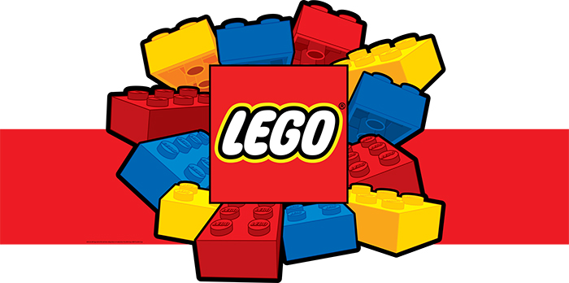

This year in our math and science lab we will be incorporating the Lego More to Math and Simple Machines Curriculum.

We would love to add some extra Legos to our collection!

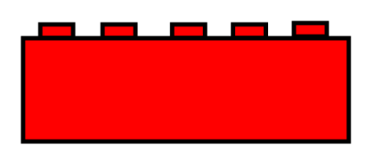Please drop off any used or unwanted Legos in the front office or send them to Mrs. Suber.

You can also help fund our STEM program by shopping on Amazon Smile or at Kroger! Details attached!

