Lesson Title: Snowman Houses
Grade Level: 3rd | Quarter: 4th
Standards:

Science:
S3P1. Students will investigate how heat is produced and the effects of heating and cooling, and will understand a change in temperature indicates a change in heat.
b. Investigate how insulation affects heating and cooling.
d. Use thermometers to measure the changes in temperatures of water samples over time

Habits of Mind:
CS6- Students will question scientific claims and arguments effectively.

Math:
MCC3.MD.1 Tell and write time to the nearest minute and measure time intervals in minutes. Solve word problems involving addition and subtraction of time intervals in minutes, e.g., by representing the problem on a number line diagram.

MCC3.MD.4 Generate measurement data by measuring lengths using rulers marked with halves and fourths of an inch. Show the data by making a line plot, where the horizontal scale is marked off in appropriate units-whole numbers, halves, or quarters.

MCC3. MD 7 Relate area to the operations of multiplication and addition.
b. Multiply side lengths to find areas of rectangles with whole-number side lengths in the context of solving real world and mathematical problems, and represent whole-number products as rectangular areas in mathematical reasoning.

MCC3.MD.8 Solve real world and mathematical problems involving perimeters of polygons, including finding the perimeter given the side lengths, finding an unknown side length, and exhibiting rectangles with the same perimeter and different areas or with the same area and different perimeters.

Lesson Essential Question:  - How does insulation affect the heating and cooling of ice?  - How do I determine the area and perimeter of a house?  - How can I use a line plot to display data? | Vocabulary:  - Heat  - Insulation  - Perimeter  - Area  - Line Plot
Lesson Materials:  - Book- Snowmen All Year by Caralyn Buehner  - Rulers, tape, scissors, graduated cylinder, ice, stopwatch, cooler, 1 paper bowl/ group  - Camera  - Ruler  Suggested materials for team designs:  - aluminum foil, plastic wrap, wax paper  - paper, paper towels  - styrofoam pieces  - clay  - felt, wool, cotton  - 10 craft sticks | Lesson Assessment:  - Student Journals  - Teacher observations
STEM Challenge Overview:

Students will design a house to place around a model snowman made of ice to keep it from melting.

Teacher Background:

Students should have investigated how heat is produced and the effects of heating and cooling. Student should understand that a change in temperature (increase or decrease) indicates a change in heat.

Prep before the challenge:
- Teachers will need to make the model snowmen by moistening three ice cubes and sticking them together in a stack (each team needs two snowman). Try to make each snowman the same size by using ice from trays.

INSTRUCTION
- Ask/Engage
Day 1 (30-45 min.)
- Read: Snowmen All Year by Caralyn Buehner
- After reading, ask the students if they have ever made a snowman before? If so, ask how long did it last before it melted? If you could take a snowman anywhere, where would it be? What would you do with your snowman?
- Hand each student a piece of ice to hold in their hands. Using stop watches, time how long it takes the ice to melt from a solid to a liquid. Teacher should create a line plot of the class’s results on the board. As the ice is melting ask questions about how it feels. Ask: What caused the ice to melt? How do you think we could prevent the ice from melting?
- Introduce the vocabulary word- insulation and discuss what insulation does (prevents heat from escaping) and examples of heat insulators (coolers, oven mitts, thermos, house insulation…..). Teacher may provide examples for the students to touch and explore.
- Introduce the challenge.
Challenge:
Every winter children build snowmen, but as soon as the weather warms up, the snowmen melt. Your team is going to design and build a house to place around your model snowman to keep it from melting. Your team will then determine the area and perimeter of the house.

- Imagine/Brainstorm
Day 2 (30-45 min.)
Introduce the challenge, criteria and constraints to the students.
Have students work independently to come up with 1-2 possible design solutions and draw/label their designs. Have students determine the area and perimeter of their design.

Criteria:
- Must have four walls
- Must have a roof
- Must cover the snowman top to bottom
- Must fit inside the bowl provided
- Must keep the snowman from melting
- Must determine the area and perimeter of design

Constraints:
- House may not be attached to the bowl
- May only use the materials provided
- Must complete the challenge in the time allotted

- Plan/Design
Day 2 Continued
Each student presents their ideas to their team.
Students collaborate to come up with final design plan.
Students draw and label final design plan and make a list of supplies they will use.

- Create / Test
Day 3 (one hour)
Teams build their design according to their plan.
Teams will share with the class the perimeter and area of their designs.
Students will test their designs all together when time is called. Have students determine the end time in order to measure time intervals. For example, if the start time is 12:13 what time will it be when 20 minutes have passed?
Each team will take a picture of their snowman house at the beginning and end of the challenge (20 min.).
As a class, once all snowmen are in their houses and pictures have been taken, have each team share their designs with the class.
At the end of the 20 minutes each team should take a picture of their snowman.
Each team will pour the melted water from their snowman into a graduated cylinder. They will then estimate and measure the water using mL.
Each team will share how much water melted from their snowman.
Once all of the measurements of water are listed, each student will create a line plot displaying the class data.
As a team the students will brainstorm ideas to improve their design.

- Evaluate/Improve – and repeat Steps 1-5
Day 4 (30-45 min.)
Students evaluate their design for success: Did it meet the established criteria? Did their final design match their planned design? How would students improve their design?

Allow students time to improve their designs. Access to more materials may be necessary and additional snowmen will need to be made.

When time is called, have students test how much water melted the second time after improving their designs.

The teacher should record the results to see how many teams improved their designs.

At the end of the challenge, the students should reflect on which materials made the best insulators. Which designs worked best? Why? Students should make a claim and support it with scientific evidence.

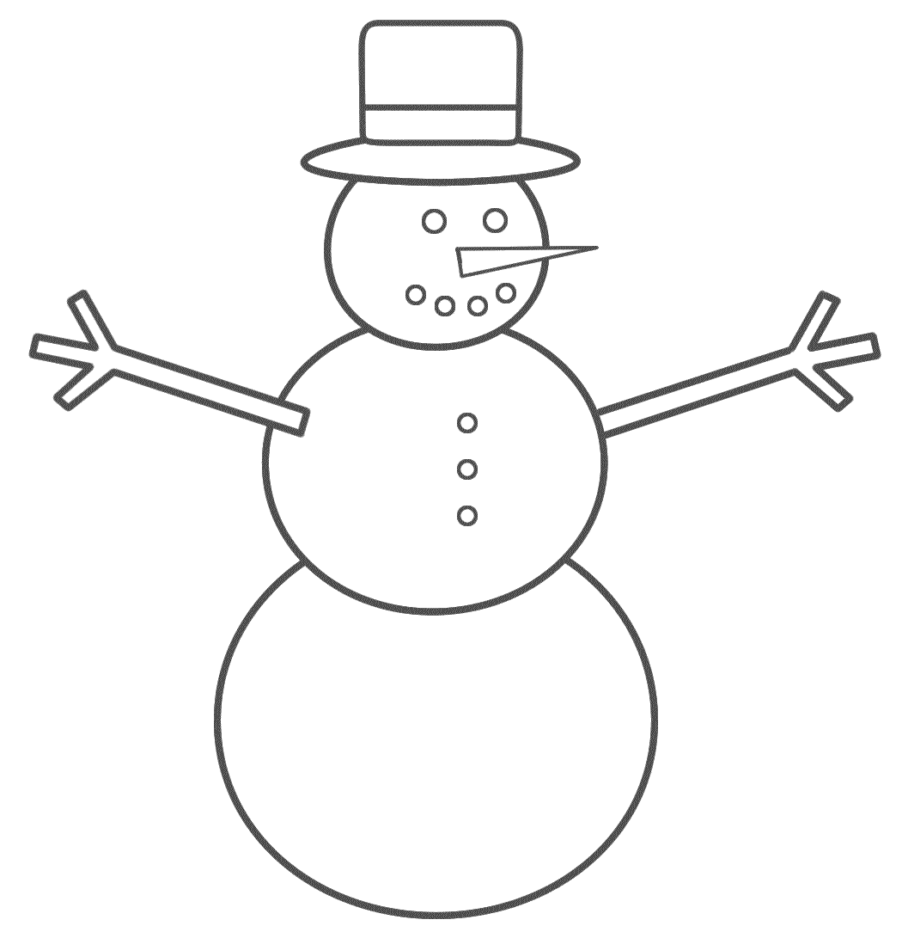
Name__________________

Snowman Houses STEM Challenge
3rd Grade

Challenge:
Every winter children build snowmen, but as soon as the weather warms up, the snowmen melt. Your team is going to design and build a house to place around your model snowman to keep it from melting. Your team will then determine the area and perimeter of the house.
Criteria:
- Must have four walls
- Must have a roof
- Must cover the snowman top to bottom
- Must fit inside the bowl provided
- Must keep the snowman from melting
- Must determine area and perimeter of design

Constraints:
- House may not be attached to the bowl
- May only use the materials provided
- Must complete the challenge in the time allotted

Materials:
Suggested materials for team designs:
- aluminum foil, plastic wrap, wax paper
- Paper, paper towels
- Styrofoam pieces
- Clay
- Felt, wool, cotton
- Craft sticks
- Ruler

- ASK / ENGAGE: What is the problem you are being asked to solve?
________________________________________________________________________________________________________________________________________________________________________________________________________________________________________________________________________________________________________________________________________________________________________________________________________
- IMAGINE/BRAINSTORM: What are some possible solutions to the problem that you are trying to solve? After you brainstorm, draw and label your ideas below.
Idea #1 | Idea #2
- PLAN/DESIGN: Share your ideas with your group and collaborate to decide on a final design plan. Draw your team’s design below and make a list of the materials that you will need to complete your design.
Team Design Plan | Materials List

- CREATE/TEST: Use your Final Design Plan to create and build your solution. Test your design. Did it work? Why or Why not?
____________________________________________________________________________________________________________________________________________________________________________________________________________________________________________________________________________________________________________________________________________________________________________________
- EVAULATE/IMPROVE: How well did your design work? Did your solution solve the problem within the given constraints?
____________________________________________________________________________________________________________________________________________________________________________________________________________________________________________________________________________________________________________________________________________________________________________________________________________________________________________________________________________________________________________________________________________________________________________________________________________________________________________
How can you improve your design? How can you make it better? Draw and label your improved design below.
Improved Design Plan

